**DAILY ONLINE ACTIVITIES SUMMARY**

|  |  |  |  |  |  |  |  |  |
| --- | --- | --- | --- | --- | --- | --- | --- | --- |
| **Date:** | **16th july,2020** | | | | | **Name:** | **Prathusha K A** | |
| **Sem & Sec** | **4th sem &b section** | | | | | **USN:** | **4AL18CS061** | |
| **Online Test Summary** | | | | | | | | |
| **Subject** | | **---------------------** | | | | | | |
| **Max. Marks** | | **----------** | | **Score** | | | **--------** | |
| **Certification Course Summary** | | | | | | | | |
| **Course** | **Cyber security roles , Processses and operating system security.** | | | | | | | |
| **Certificate Provider** | | | **Coursera** | | **Duration** | | | **4 weeks** |
| **Coding Challenges** | | | | | | | | |
| **Problem statement: No coding** | | | | | | | | |
| **Status: -----** | | | | | | | | |
| **Uploaded the report in Github** | | | | | **yes** | | | |
| **If yes Repository name** | | | | | **https://github.com/prathu47/lockdown-reports** | | | |
| **Uploaded the report in slack** | | | | | **yes** | | | |

Certification Course Details: (Attach the snapshot and briefly write the report for the same)

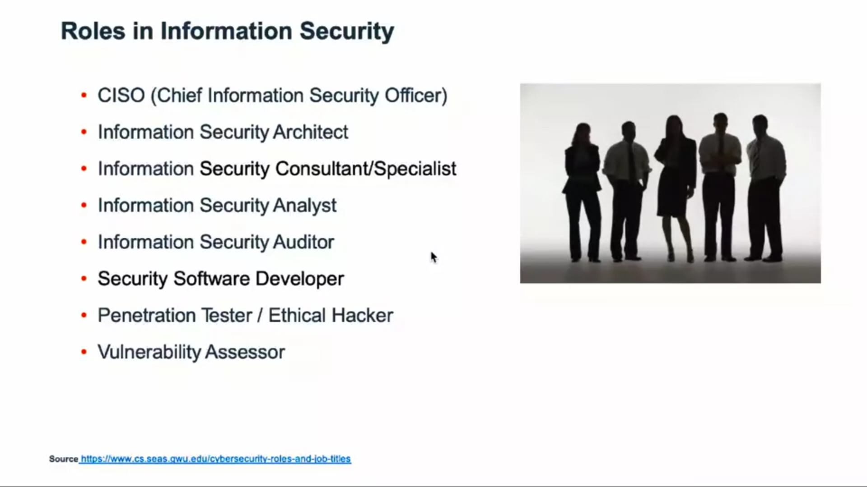

The course I have chosen during the lockdown period is Cyber security roles, processes and operating system security . since I was interested in cyber security I optted for this course . Today learnt about roles in information security.

Coding Challenges Details: (Attach the snapshot and briefly write the report for the same.

Coding challenge: No coding solution has given.